Newsletter
Term 2 Week 2
May 11, 2022

What's going on?
9-13 May | Road Safety Week
13 May | Whole school assembly 1:45 pm
16-20 May | Bully Free Week  Pink Shirt Day Friday
18 May | New parents morning tea 9:45 am
19 May | Scholastic Bookfair arrives
23-27 May | Book week  Parade on Friday
25 May | Hungerball arrives  BOT meeting 7pm  Parent Education afternoon-Hero 2:45pm
26 May | Wear ORANGE for PWS month
27 May | Room 1 visiting Tomarata Playcentre
1 June | Garden to Table Bake Sale
6 June | Queen's Birthday-NO SCHOOL
10 June | Whole school assembly 1:45 pm
13 June | Teacher Only Day-no school
15 June | Yr ⅞ Tech
17 June | Grip Leadership Conference for House Captains-Albany
22 June | Yr ⅞ Tech

Birthdays
Nova & Roman Saxby
Isaac Kerrigan
Bella Mawson

Mrs Neel’s Notes:

Dear families & whanau
Kia ora, kia orana, talofa, malo e lele, kon’nichiwa, hello
Our calendar for this term seems to be getting busier & busier. Please check here or on the website for what is coming up that involves you & your children. Some teachers have posted Term 2 newsletters on HERO, so have a read of those too. Lots of awesome activities are coming up. They also provide specific class information that is relevant to each room. Rooms 1 & 2 are looking forward to a visit to Kelly Tarltons- date TBA.
Our strategic & annual plans have been approved by the Board, & sent into the Ministry of Education. Both the strategic plan & the annual plan are available to see on the school website. Our journey with Schools That Deliver, along with community consultation, continue to guide our school’s direction.
The Rodney Rural Schools Hockey/Soccer day is coming up on the 28th June. We will be asking for parent help nearer the time for the sausage sizzle & to sell food. We would love to have as many helpers as we can PLEASE to spread the load. Be assured that you will still have time to watch your children, as well as supporting the school. So can you check your diaries now?
People have been asking if we will be holding school discos again, & the answer is YES! Our very eager Student Voice is planning one soon….so watch this space!
Some teachers attended professional development on Structured Literacy this past holiday. Thank you to the 2 parents that attended the information afternoon held last week. Their response was very positive.
We also held our very first Welcoming Ceremony for new students attending Tomarata School last Friday. I have to say it warmed my heart. The waiata sung by the children was beautiful, including Room 1’s special song. Each child was presented with a native tree to plant , to watch grow over their educational journey at Tomarata School. It was followed by a lovely morning tea prepared by Room 3 & Mrs S. his ceremony will be held at the start of every term to welcome any new students who have joined our Tomarata family.
principal@tomarata.school.nz
____________________________________________________
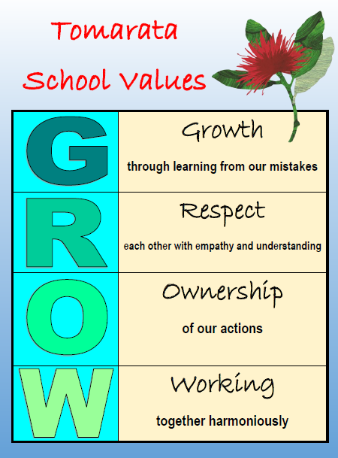

Our Vision
Knowing what makes each child tick enables us to cater for each of their unique gifts even if that sits outside of traditional approaches of the National Curriculum. Teachers spend a lot of time listening to & observing their students. By doing this they get to know their children deeper. You know your children well as you have watched them grow & change over the years. We have your children for such a short time, so it’s important that we learn what their skills & talents are; & what areas they find hard. Any help you can give us with this would be much appreciated.
As you have seen we do things quite a bit different at Tomarata School with our Environmental Tuesdays; our Fun Fridays; our Nature classroom; our Makerspace to name but a few. We are designing our local curriculum to reflect the environment you, your children & our school is situated in.
Tomarata School Shared Vision can be read in full here.

Reminders
Please check our Lost Property clothes line for items of clothing that may belong to your children. It is on the wall by the doorway to the Library.It would be EXTREMELY helpful if clothing was named so it could be returned to its rightful owner too!
Bus concerns:
- Children are to be picked up at the bus door.
- No children should be crossing the road without a parent.
- All children should be at the bus stop 10min prior to the scheduled time.
These concerns are coming from the bus drivers. Please do follow them.

PB4L Focus
This week teachers & children have been recovering Respect, & looking at all areas where that value is used. Respect for themselves, each other, property & equipment & the environment.
Andie McGuiness andie@tomarata.school.nz

Shout outs
Thank you to the following students who have shared their cool work with me
Teilah Melrose & Livingstone Sionetali-Raki Room 6 who shared their very scary Horror Story. It gave me goosebumps!
Room 6 for supplying me with Bacon pasta & lettuce & mandarin salad with lemon dressing. I am thoroughly enjoying my Garden to Table menu dishes every week, that use produce that the children have grown themselves
VALUES ASSEMBLY
These wonderful students received recognition on Monday
Eddie Cammell Room 6 for Growth
Levi Gray Room 7 for Respect
Nova Saxby Room 1 for Ownership
Ava Pieper Room 1 for Working Together
CONGRATULATIONS!
Community
The teachers are planning something special for Bookweek, & Room 6 is building a pirate ship. We are in need of large cardboard boxes like fridge boxes. If you have any can you please drop them off at the office. THANKS!
I have at least 6 sleeping bags that were donated to us by Te Whai Trust. If you would like one or two, please drop me an email or see Vicki in the office.They will cost you nothing.
Lots of thanks to Pip White who is working on our new school brochure. We are going to include ideas & information from our Year ⅞ children so that their voice is heard about how they feel about our school.

Welcome to...
Kristy Lowe & Michaela Kemp , student teachers in Room 7 & Room 3. We hope you enjoy your time with us.

Help Needed
We were unable to get free paint from Resenes as we’d hoped to, to jazz up our front entrance to make it more welcoming. If you have any white, black or red outdoor house paint, & undercoat we would love to take it off your hands.

BOT Update
We are having our next board meeting, Wednesday 25 May and you are welcome to attend. These meetings are held at Tomarata School at 7pm and are always open to the public.
Jason Kerrisk boardchair@tomarata.school.nz
Garden to Table
HUGE thanks to Ash Barker for her donations of seeds, & Martha Korewha for the wonderful assortment of equipment for our class kitchen. You ladies are fab!
Room 6 is now selling hot peppermint chocolate on Tuesdays for $2 a cup. I can totally endorse it- it’s delicious!
The list of needed equipment for our GARDEN TO TABLE programme is below. If you have any of the following, & are willing to donate them to the school we would be very, very grateful. As items are donated they are removed from the lists. Bolded blue items desperately required
GARDENING
Herb/Tea/Medicinal Garden: Lemon Balm, Borage, Comfrey, Fennel, Anise, Caraway, White Mustard, Celery
SOIL- Lots (trailer load)
Gypsum - 1 bag (for clay)
Compost min 2m
Sheep Poo
Olla Pots (Clay Pots with lids) - watering system
Garden Scissors x2
3 Spray Bottles (Heavy-duty)
Flat-bed Trolley
Sledge Hammer
KITCHEN
3x serrated knives
2x small paring knives
2x citrus juicers
Measuring scales ideally electronic
1x pastry brush
1x colander/strainer
Microwave
Beater
Tall pantry type cupboard
Set of drawers- plastic or trolley type would do
Fry pans
1x muffin tray
6x serving spoons/forks
Cleaning supplies (cloths/scourers/brushes/gloves)
Tea towels
Handee towels/ foil
2x containers for compost/worm farm scraps

FIREWORKS EXTRAVAGANZA NIGHT
SAVE THE DATE! Fireworks Extravaganza
12TH NOVEMBER
Our Fireworks team are as follows:
Paula Bishop
Anne Richards
Shannon Josephs
Hayley Hawke
Robyn Sibtsen
Cherylene Neels
Planning & preparation is coming along well. Food vendors are booked, and the Cricket Club notified.
HOWEVER URGENT!: The cover band “Happy Fish” that we have always used for our Fireworks night is unavailable this year. If ANYONE knows of a good cover band that could be our entertainment please contact Anne Richards at peteanneplus3@gmail.com
Just for a Giggle:

OUR AMAZING SPONSORS
Please support our sponsors by making your purchases with them.
We really appreciate your help:
Carters Mangawhai
Hammer Hardware Wellsford
Top Shop 4 Square Wellsford

Mangawhai Meats
Andy Dwen NZCI Ltd

0274 865 831

