Newsletter  
Term 3 Week 2 

August 4 2021

# What's going on?

| 4 August | New parent’s morning tea  Yr ⅞ tech |
| --- | --- |
| 6 August | Travelwise Truck Safety Day  Whole school assembly |
| 9 August | Wellness checks by PHN-Maretta |
| 10 August | Parent Education session on HERO 3-4 pm |
| 11 August | Year ⅞ tech |
| 18 August | Rodney College visiting Year 8’s  Year ⅞ tech |
| 20 August | Whole school assembly |
| 24 August | Parent Education afternoon 3-5 pm on Reading |
| 25 August | Rodney College Open Evening 4:30-5:30 pm |
| 26 August | Parent forum 6-7 pm |
| 27 August | Daffodil Day |
| 30 August | TOD-school closed |
| 1 Sept | Yr 7/8 Tech |
| 2 Sept | Maori Consultation Forum 6-7 pm |
| 3 Sept | RRS Netball/Touch day Year 4-8 |

# 

# Birthdays

## 

Molly Barnes

## Mrs Neel’s Musings

## 

## Dear families & whanau

Kia ora, kia orana, talofa, malo e lele, kon’nichiwa, hello

The week began on a high note with our successes at the Olympic Games, and the successes of our Year ⅞ students who auditioned for roles in our end of term Production. I am enjoying the excitement levels already!

As you know our motto for Tomarata School is Poipoia te kakano kia puawai: Nurture the seed and it will blossom. To bring this part of our Vision to life we have decided to name our teaching areas of the school. Our NE-Year 2 classes will be known as “Seeds'' - Kakano; our Year 3-4 will be known as “Shoots” - Tupu; our Year 5-6 will be known as “Saplings” - Mahuru; and finally our Year 7-8 will be known as “Trees” - Rakau. If you look closely at the postboards of our Values tree that are up around the school, & in the office, the 4 parts are incorporated into the whole tree. The signs for the age groups are up by the classes now too. Go & have a look!

Our first parent education afternoon on using HERO will be on the 10 August. If you want some tips, or to see what HERO can show you, please come along.

Some of our classes have been celebrating 100 days (so far) at school this week, in a variety of ways. The collections of 100 things were amazing, as was cutting Room 7’s cake into 100 pieces! I have 100 stickers in my office drawers. But these are being depleted by all the great work that I have the privilege of seeing nearly every day.

*Wastewise wisdom:*

*Did you know that bread is the number 1 food wasted in New Zealand? Store it in the fridge or freezer to stop it going mouldy!*

[**principal@tomarata.school.nz**](mailto:principal@tomarata.school.nz)

__________________________________________________

# Our Vision

***Our children learn how to learn and are taught the way that works best for them.***

Children can learn by osmosis, however they do need to be taught specific knowledge. Every core curriculum area has specific skills & strategies that build on each other as they increase in complexity. Reading starts off by learning to read letters, words and punctuation, to reading to learn by using literal & inferential comprehension. Writing starts with drawing pictures & writing a sentence about them to writing essays with paragraphing. Maths starts with recognising numbers & learning to add & subtract, to solving problems knowing what mathematical strategies need to be used including multiplication & division. The teachers teach the specific knowledge required at each level.

Children learn in different ways- some by seeing; some by listening & others by doing. Some learn by a combination of all 3. Teachers use a variety of methods to teach each student in the way that best works for them.

[**Tomarata School Shared Vision can be read in full here.**](https://docs.google.com/document/d/1XODboho0oPxNrrgrYJLnFEDEXMDfTnPQM5TEWitL2wk/edit?usp=sharing)

# Reminders

We have lip balm and lemon honey for sale all made by Room 3 & Room 7. Please support the children’s efforts by purchasing them from the office.

# PB4L Focus

Our PB4L focus this week is on really unpacking the Ownership part of our GROW values. It is really important that children learn to take ownership of their actions, displaying empathy & compassion. At school we teach them this phrase- OWN IT; FIX IT; LEARN FROM IT; MOVE ON. Children will model what they see you as adults & parents do. The moving on statement is very important, as no one can live a healthy life if they continue to carry baggage on their backs by not letting go of old hurts or actions.

[Tomarata School Behaviour Plan can be read here](https://drive.google.com/file/d/12XgEtYd8ZOOrOE3T_Z4Pi6A_nCeBv83t/view?usp=sharing)

# Shout outs

**Students**

Congratulations to the following students who earned the Values mascots at assembly on Monday.

Cate Richards for Growth; Eden Harris for Respect; Cherish Menzies for Ownership and Hemi Hobbs for Working Together Harmoniously. Awesome effort guys!

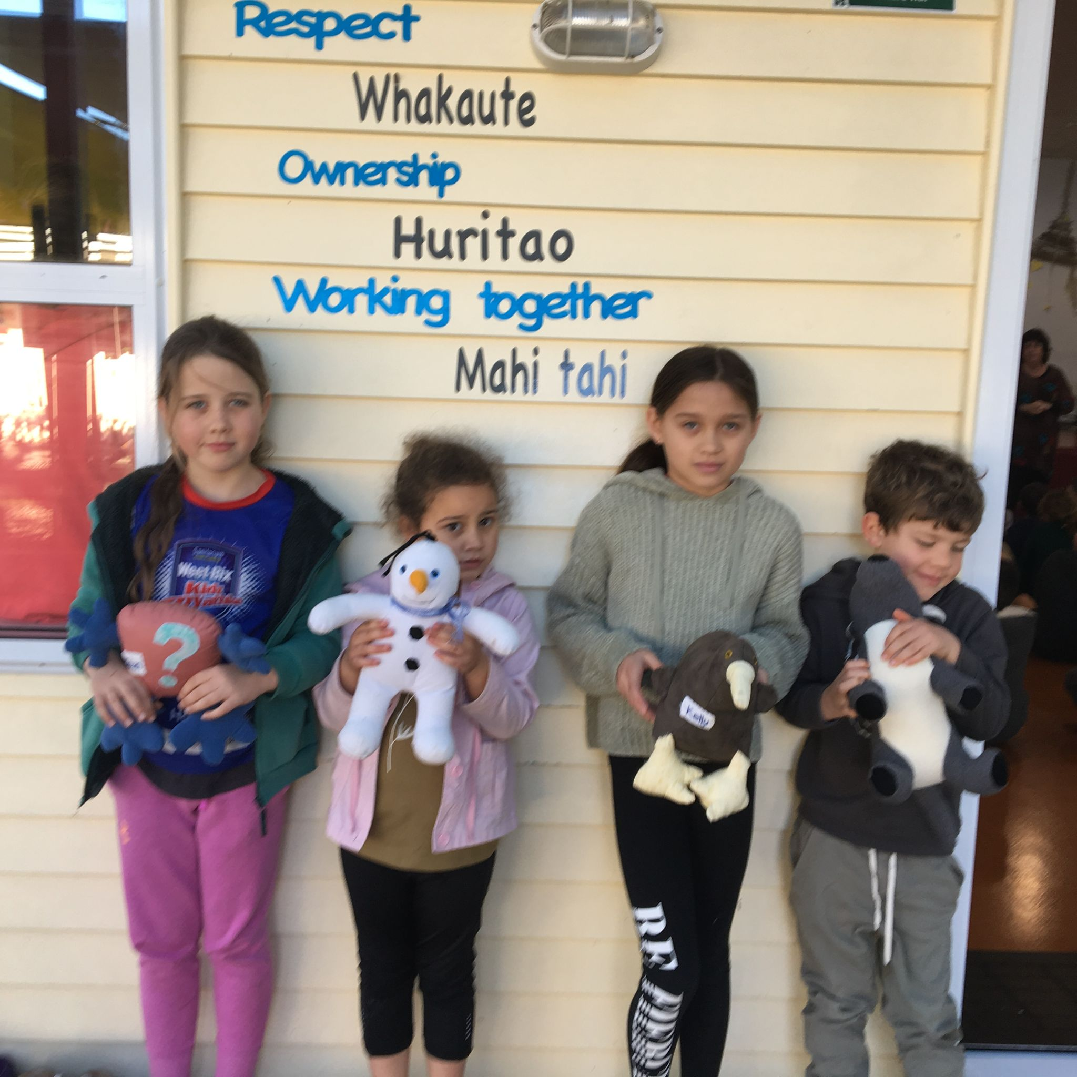

ART INFO.

Here are some photos of the Art Day at the Wellsford Library. What a brilliant experience for our kids!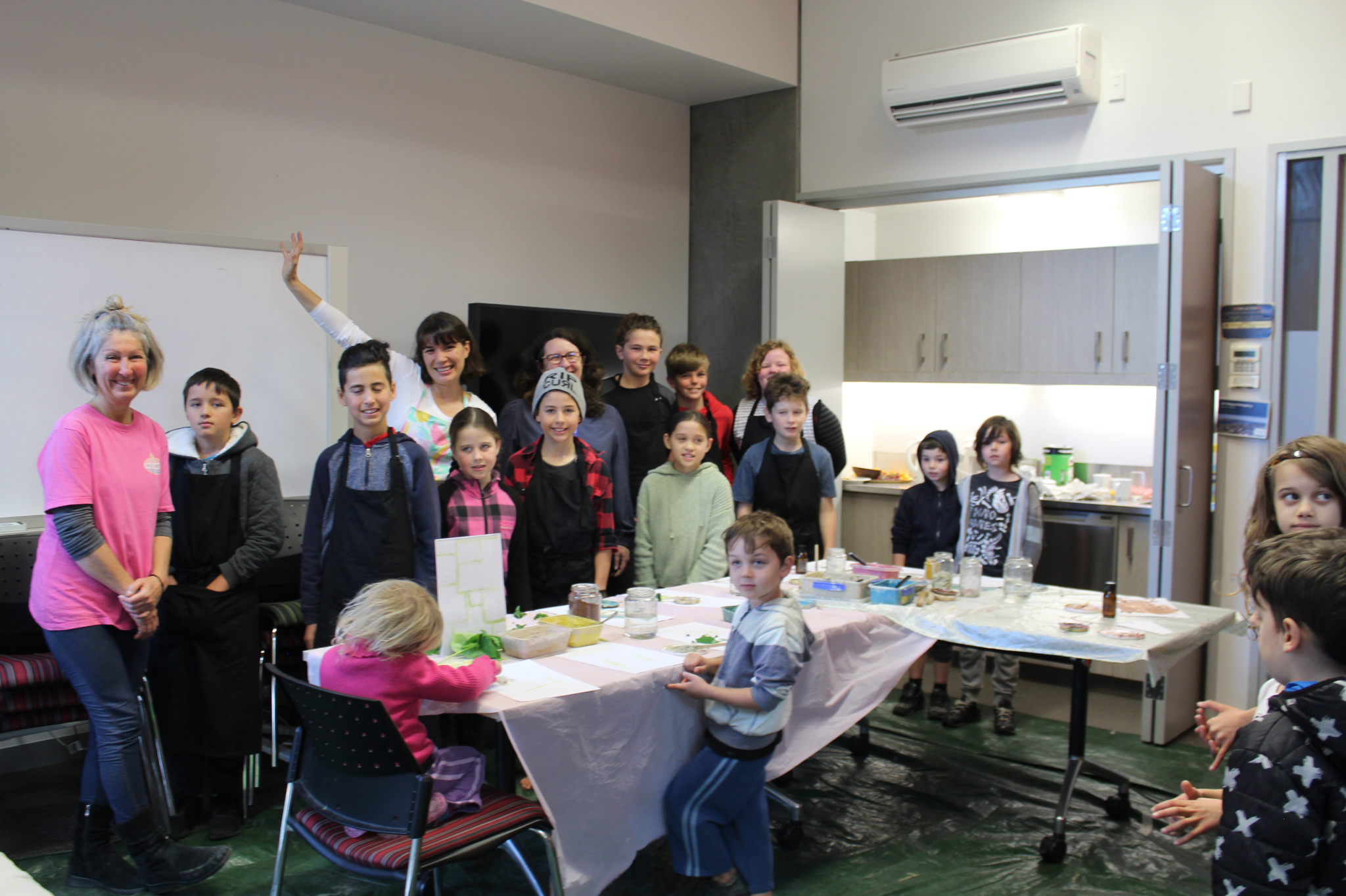







Community

You may have noticed that the front gate gets very congested at the end of the day with our bus children lining up, as well as the children who get picked up by car trying to get out of the gate, or parents trying to get in. To ease this we have decided that the children not going on the bus will go to the other side of the PE shed, & leave through the gate there. A teacher will accompany the children & bring back any that are not picked up straight away, to the office. So please head there if you are collecting your children. Hopefully this will make congestion at the front gate a lot more manageable.

**PRODUCTION**

Don’t all jump for joy at once-it will cause an earthquake. This year we are planning to hold a whole school production at the end of Term 3 2021. The title of the production is “HISTORY ROCKS” and is the story of music through the ages alongside the concepts of bullying, loss, friendship and self-confidence. Each class will have a song to sing, dance and act to. A production also encourages our gifted children to showcase their amazing talents as lead actors and dancers. The virtue of hard work and our GROW Values will also encourage our children to do their best in The Arts. To make this production successful

” WE NEED YOU”to help with

* Props & scenery
* Costumes
* Helping backstage
* Front of house
* dance teachers
* A photographer
* Sound technician
* Lighting
* Microphones

If this sounds like you please contact Mrs Neels at school.…it’ll be a blast!

# Parent Forum

Our next Parent Forum will be on Thursday 26 August at 6 pm in the staffroom all are welcome. We will also be holding a Maori Whanau Consultation night on Thursday 2 September at 6 pm. We would like our Maori whanau to attend, as well as in other interested families, to discuss what Tikanga Maori could look like at Tomarata School.

Helping Hands Update

New members desperately needed. Please contact Erica for details.

**To contact HH please email Erica Casey** helpinghands@tomarata.school.nz

# BOT Update

Our next Board meeting is Wednesday the 25th August at 7 pm in the Boardroom. All are welcome.

**To contact the BOT please email**

**Jason Kerrisk** [boardchair@tomarata.school.nz](mailto:boardchair@tomarata.school.nz)

HERO

For information about HERO, including how to log in go to

<http://go.linc-ed.com/>

Community Notices.

**CATWALK ARTS WEARABLE ART AWARDS** Sat 28th August 2021 Mahurangi College. Please see our facebook page for more information

**Tomarata Playcentre**

619 School Road, RD 4, Wellsford

[tomarata@Playcentre.org.nz](mailto:tomarata@Playcentre.org.nz)

09 423 9074 Tuesday, Thursday & Fridays 9.30-12pm

Just for a Giggle

