Newsletter
Term 2 Week 9
June 30, 2021

What's going on?
30 June | BOT meeting 7 pm
6 July | Paid union meeting for teachers - School closed from midday
8 July | Whole school planting day-Tomarata Lakes
9 July | Parent Teacher Interviews: children at home  Last day of Term 2
26 July | Term 3 begins
6 August | Whole school assembly
18 August | Rodney College visiting Year 8’s
20 August | Whole school assembly
24 August | Parent Education afternoon 3-5 pm
25 August | Rodney College Open Evening 4:30-5:30 pm
27 August | Daffodil Day

NB: Friday 9 July is like Day 1 interviews. School is open for interviews only. The children DO NOT come to school as usual. They can come with you ( parents) for the Interviews if you wish them to be there.

Birthdays
Khodi Paikea Room 5

Mrs Neel’s Musings

Dear families & whanau
Kia ora, kia orana, talofa, malo e lele, kon’nichiwa, hello
Two more weeks and it will be time for a well deserved break for the holidays. Everyone is feeling tired, and often at this time of the term children’s behaviour takes a downturn, so the teachers will be keeping things very tight. Unfortunately we don’t have the same control over adults. I’ve been contacted by another school to say that some unsportsmanship-like comments were made on the playing fields at Port Albert. It is a timely reminder that we should always be modelling respect for others in front of our children wherever we are & whatever we are doing.
Make sure that you go to the Wellsford Library during the holidays. Tomarata School has a wonderful display there of artwork, done by the Seniors with Geva Downey last year. It is named “With the Light of the Night”. Some of our students will also be running art lessons onsite during the holidays, so it would be worthwhile to make a trip.
Next week the whole school, & the country, will be celebrating Matariki, which is the start of the Maori New Year. There will be a variety of activities happening throughout the week. We have already started with a wishing tree, which is in the school Library. Look out for the 7 sisters in the night sky over the next few nights.
I have had some information that there will be a large number of logging trucks moving past the school for a period of 4 weeks. This will start from 19 July. Please be aware of this when dropping off & picking up your children next term.
The children have been showing an interest in swapping Pokemon cards lately. This is a fun activity, however the Juniors do not necessarily understand the concept of swapping &/or the value of cards. Due to this, we have had upset children who don’t understand why they can’t have their cards back. We have decided to ban using Pokemon cards at school at the moment, until we sort out some rules & supervision.
We have a new tray of lip balms for sale , as well as some gorgeous earrings that some students made with Ms Wade at lunchtimes. A great skill to be learning. Please purchase these at the office- cash only.
principal@tomarata.school.nz
__________________________________________________

Our Vision

We go above and beyond to plan a programme that offers a range of options and opportunities for each child.
Engaged children are happy children. Happy children are eager to learn. To engage children teachers try to design programmes that are interesting , & provide opportunities for every child to learn from. This is not as easy as it sounds, as every class is made up of children with different likes & dislikes. It is like trying to design a menu that is going to suit every person’s taste buds. The teachers try the best they can, plus we have programmes such as our CRT with Matua Chris, art with Geva & Mindy, Discovery time in the Juniors etc. We will continue to develop our Local Curriculum in order to offer a range of options & opportunities for our children.
Tomarata School Shared Vision can be read in full here.

Reminders
We would like every student who represents the school outside of school grounds to wear the Tomarata Sports tee-shirt. If you don’t have one, please purchase from the office at $20 a shirt.

PB4L Focus
Our PB4L focus this week is on being able to use the PE shed correctly. This is teaching children to take responsibility for borrowing sports equipment; using it in the right way; & then returning it correctly. It reinforces the values of Respect (for property) & Ownership of their actions. Not kicking balls by classrooms so they don’t end up on the roof; not leaving sports equipment outside overnight; using items correctly so they don’t break….these are important skills to learn. This can be reinforced at home by how children treat their, & other toys or belongings like bikes. It also reinforces the concept of borrowing items correctly as adults.
Tomarata School Behaviour Plan can be read here

Shout outs
Students
Awesome effort to the following students who received the Values mascots on Monday: Liana Rm 7 for Growth; Eva Rm 3 for Respect; Maddie Rm 2 for Ownership ; Ayla Rm 6 for Working Together Harmoniously.
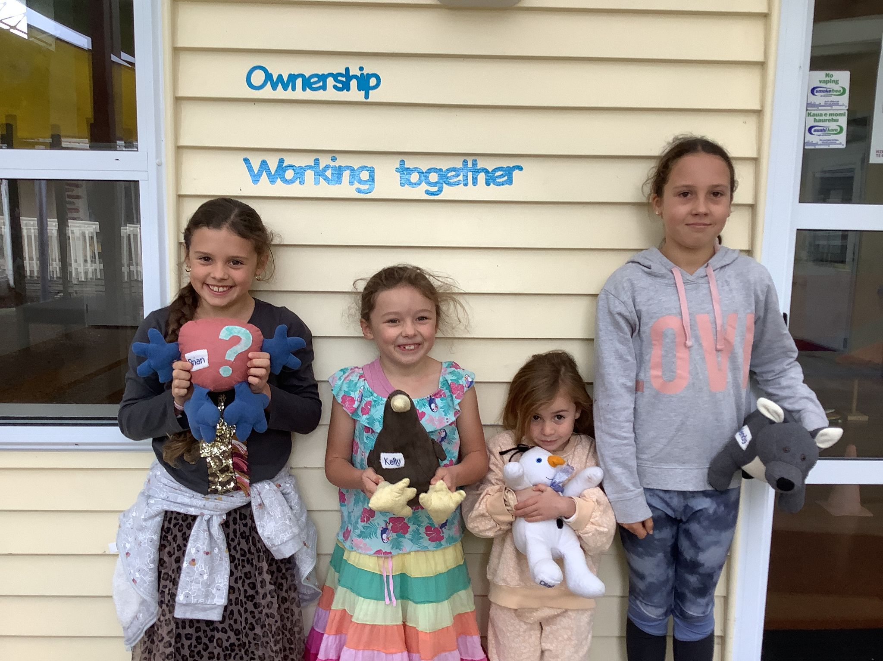
Congratulations to the following students who received awards at last week’s assembly: Principal Awards- Ellie Russell, Ruby Richards, Eden Harris & Ayla Brien. Ticket awards- Cherish & Connavar for Growth; Clancy for Respect & Ran for Working Together Harmoniously. Star of the week was Max Davis.
We were very lucky to have been shown some exquisite artwork from Room 7 as well. They used the medium of pastels, & produced pieces that they all can be very proud of.
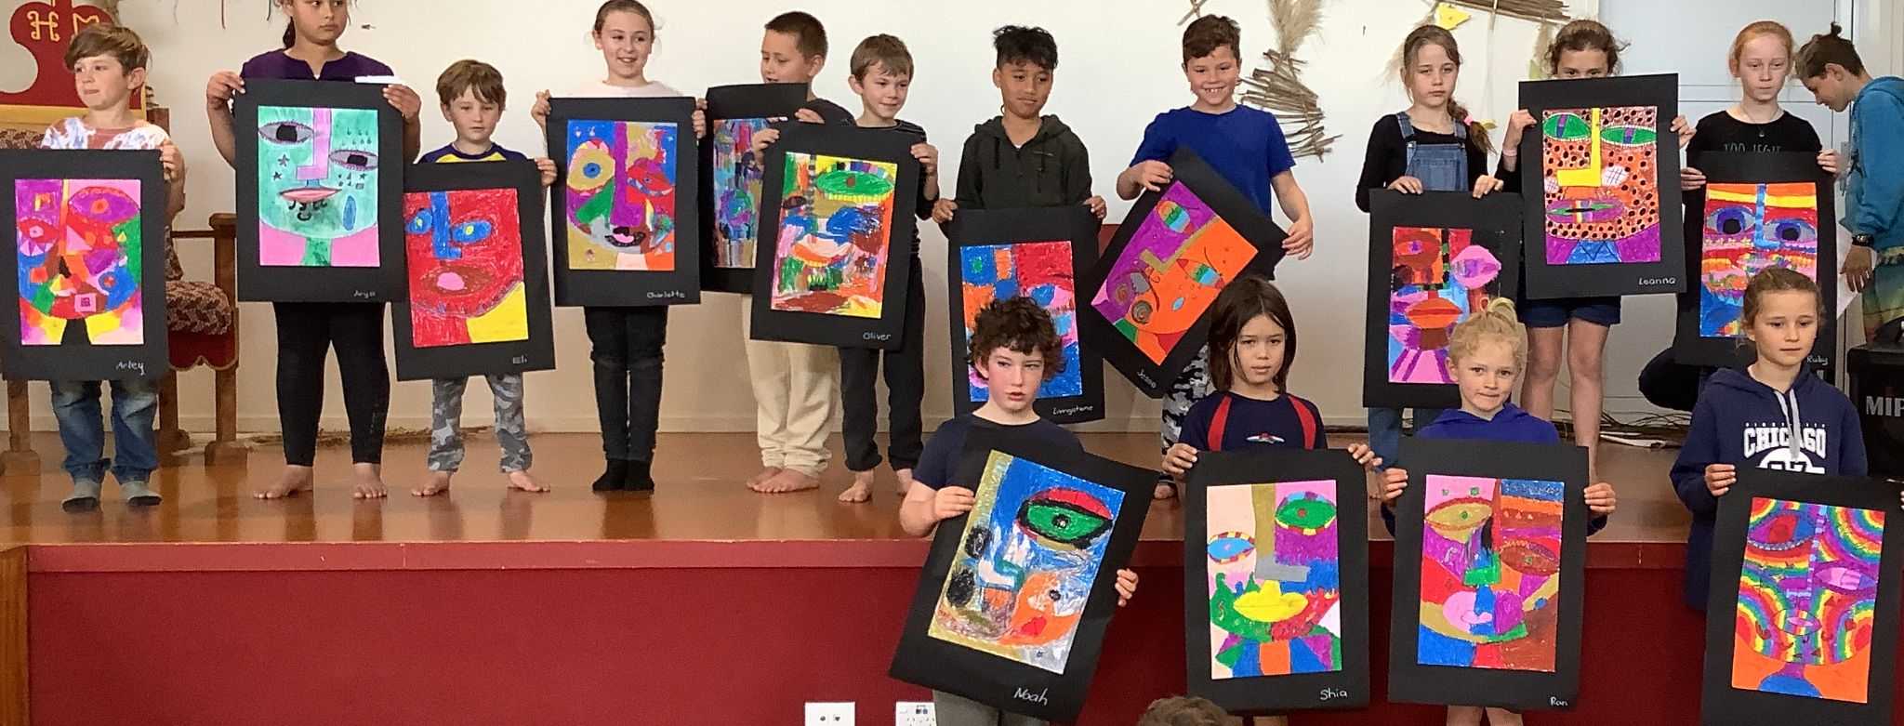

The school was also lucky to be entertained by a group of enthusiastic dancers who had put together an item for us. Well done to Liana Kerrisk, Rosalie Bowman, Ruby Richards & Cate Richards. We really enjoyed your creativity.
Lastly, well done to Aurelia Ryan for meeting the special challenge that I set her. You made me proud!

ART PAGE.
Room 5 have been working together harmoniously when doing art with Geva.
We’ve used Indian ink to paint a journey we’ve taken. Also, we’ve created colours with clay and reassembled them to put up in the Auckland library for other people to see.
Last Friday we learned about different symbols that represent different objects.
We’re using dye to colour one piece of paper each. After we do that we have to try and spot little pictures in the midst of the spectacularly special splash of creamy cloudy colours.
We’re trying to pull out the characteristics within it. Everyone is enjoying the experiment with different colours. Using white Indian ink to add some ghostly colours to it, we outline our images within the paper with black vivid to make them stand out so they’re easily visible. There is so much detail and thought going into the artwork we’re creating it’s definitely the highlight of some children's week so far. It’s almost like I can just snatch the excitement out of the air!!

By Jack Clements Room 5Today
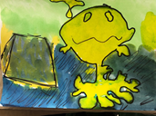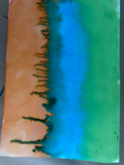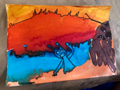

Room 7 have been working with Geva outside in this spectacular sunshine. They are creating art experimenting with natural pigments from turmeric, plants, and charcoal.

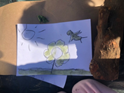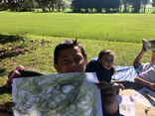

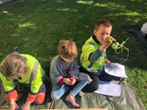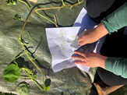

Community
Our mid year reports will be ready to be accessed by you digitally, using HERO, on Thursday next week. Look out for the information on how to access them. Remember to book an appointment online, for an interview with your child’s teacher . Please go to www.schoolinterviews.co.nz & enter the code wxdjp.

Welcome to...
Brock Ecroyd and Nile Ahern who have started school. We love having you as part of our Tomarata School whanau.

Parent Forum
Our next Parent Forum will be on Thursday 26 August at 6 pm in the staffroom. All welcome
We will also be holding a Maori Whanau Consultation night on Thursday 2 September at 6 pm. We would like our Maori whanau to attend, as well as in other interested families, to discuss what Tikanga Maori could look like at Tomarata School.
Helping Hands Update
Lunches last Thursday raised $134.00 for the school. Thank you to our super parents !
We are still needing a few helpers on Saturday the 3rd of July at 9.30am to help make sandwiches 🥪 for the car rally.
To contact HH please email Erica Casey helpinghands@tomarata.school.nz

BOT Update
Our next Board meeting is on Wednesday 30 June at 7 pm in the Boardroom. All are welcome.
To contact the BOT please email
Jason Kerrisk boardchair@tomarata.school.nz
House Captain Hello
Thanks to Hagan Logue who will be assisting the House Captains in constructing the roadside stall.
HERO
For information about HERO, including how to log in go to
http://go.linc-ed.com/

Community Notices.
CATWALK ARTS WEARABLE ART AWARDS Sat 28th August 2021 Mahurangi College. Please see our facebook page for more information

Tomarata Playcentre
619 School Road, RD 4, Wellsford
tomarata@Playcentre.org.nz
09 423 9074 Tuesday, Thursday & Fridays 9.30-12pm

Just for a Giggle
