Newsletter
Term 2 Week 5
June 2, 2021

What's going on?
2 June | Year ⅞ Tech
3 June | Hearing & Vision testing
7 June | Queen’s Birthday-no school
8 June | Parent Forum 6 pm in staffroom
9 June | Year ⅞ Tech  Footsteps Dance Company starts
11 June | Whole school assembly
17 June | Sausage Sizzle & Pizza Whanau Fun nite 4 pm onwards
18 June | Rodney Rural Schools Soccer/Hockey tournament
25 June | Whole school assembly
6 July | Paid union meeting for teachers - School closed from midday
8 July | Whole school planting day-Tomarata Lakes

Birthdays
Kylieshianne Kingi & Liana Kerrisk

Mrs Neel’s Musings

Dear families & whanau
Kia ora, kia orana, talofa, malo e lele, kon’nichiwa, hello
What a wonderful couple of weeks we have had. Book Week was fantastic with teachers & children participating in all sorts of activities. The class windows are brilliant, & who could forget our fabulous character parade last Friday. Nearly every child was in costume, & all staff. The following students were deemed best dressed in classes:
Room 2: Felix Tipping 1st & Harper Ferguson (HC)
Room 3: Payson Ecroyd 1st & Nathan Baker (HC)
Room 7: Arya Mitchell 1st & Rosalie Bowman (HC)
Room 6: Kyle Watson-Walker 1st & Ellie Russell (HC)
Room 5: Isaac Kerrigan 1st & Jack Clements & Leon Richards (HC)
principal@tomarata.school.nz
____________________________________________________
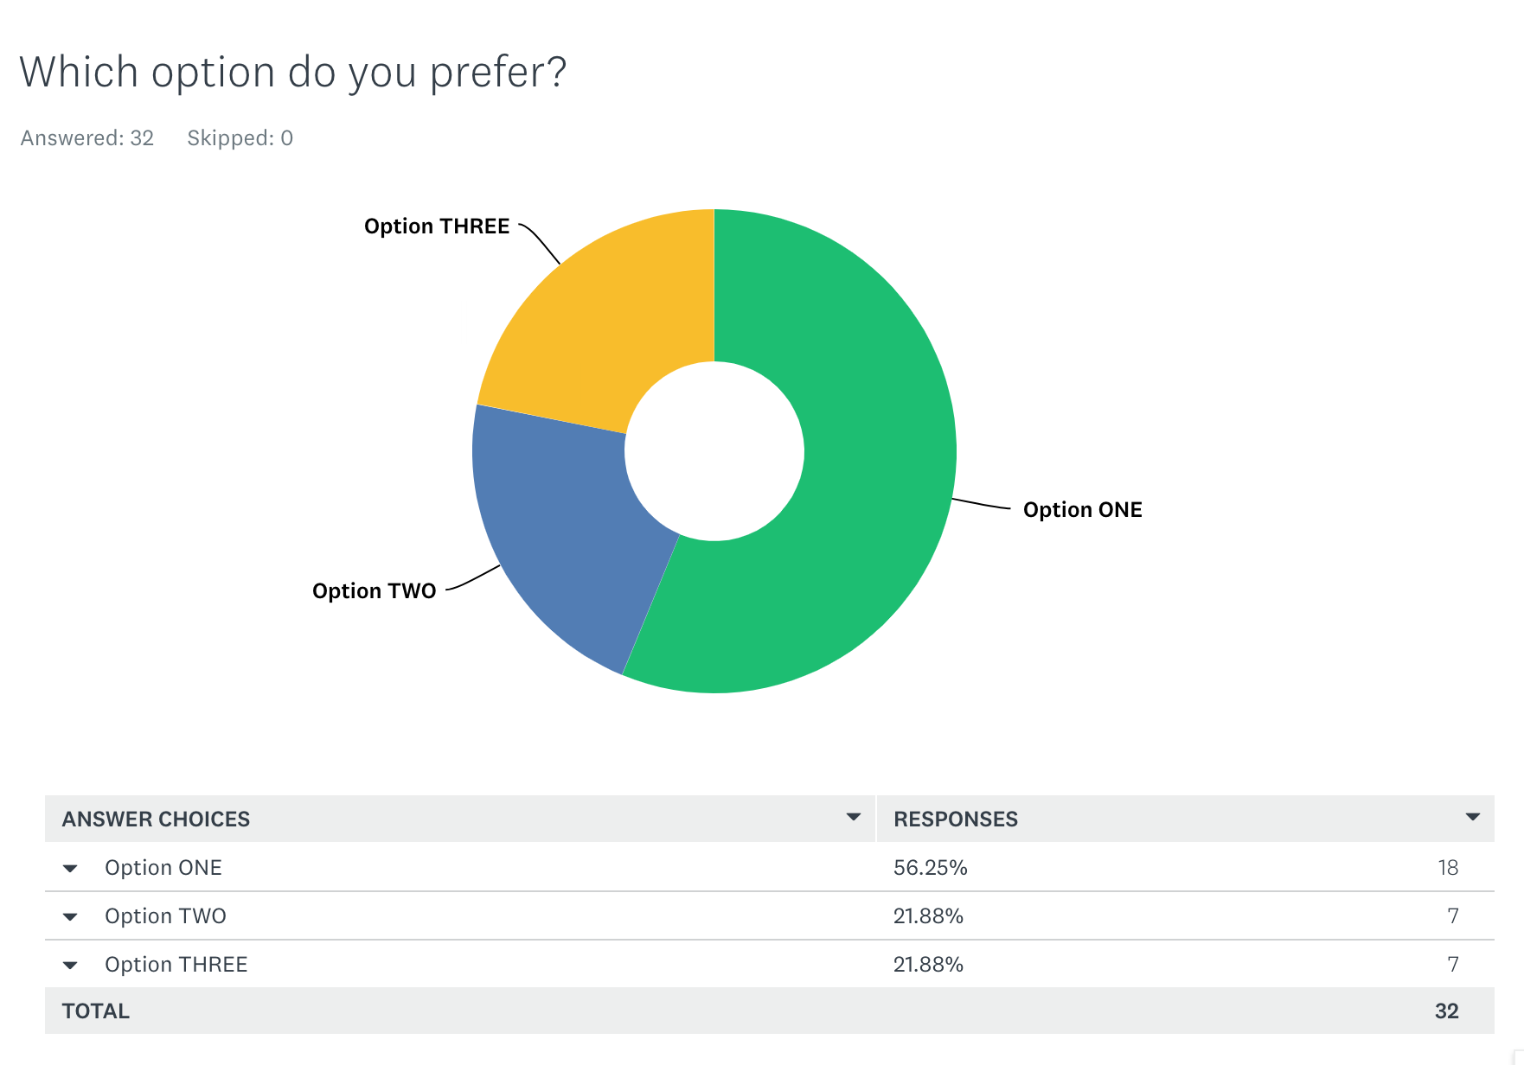
We have had an overwhelming majority vote for the tree symbol for our GROW values. Many thanks to Pip White for her amazing designs.

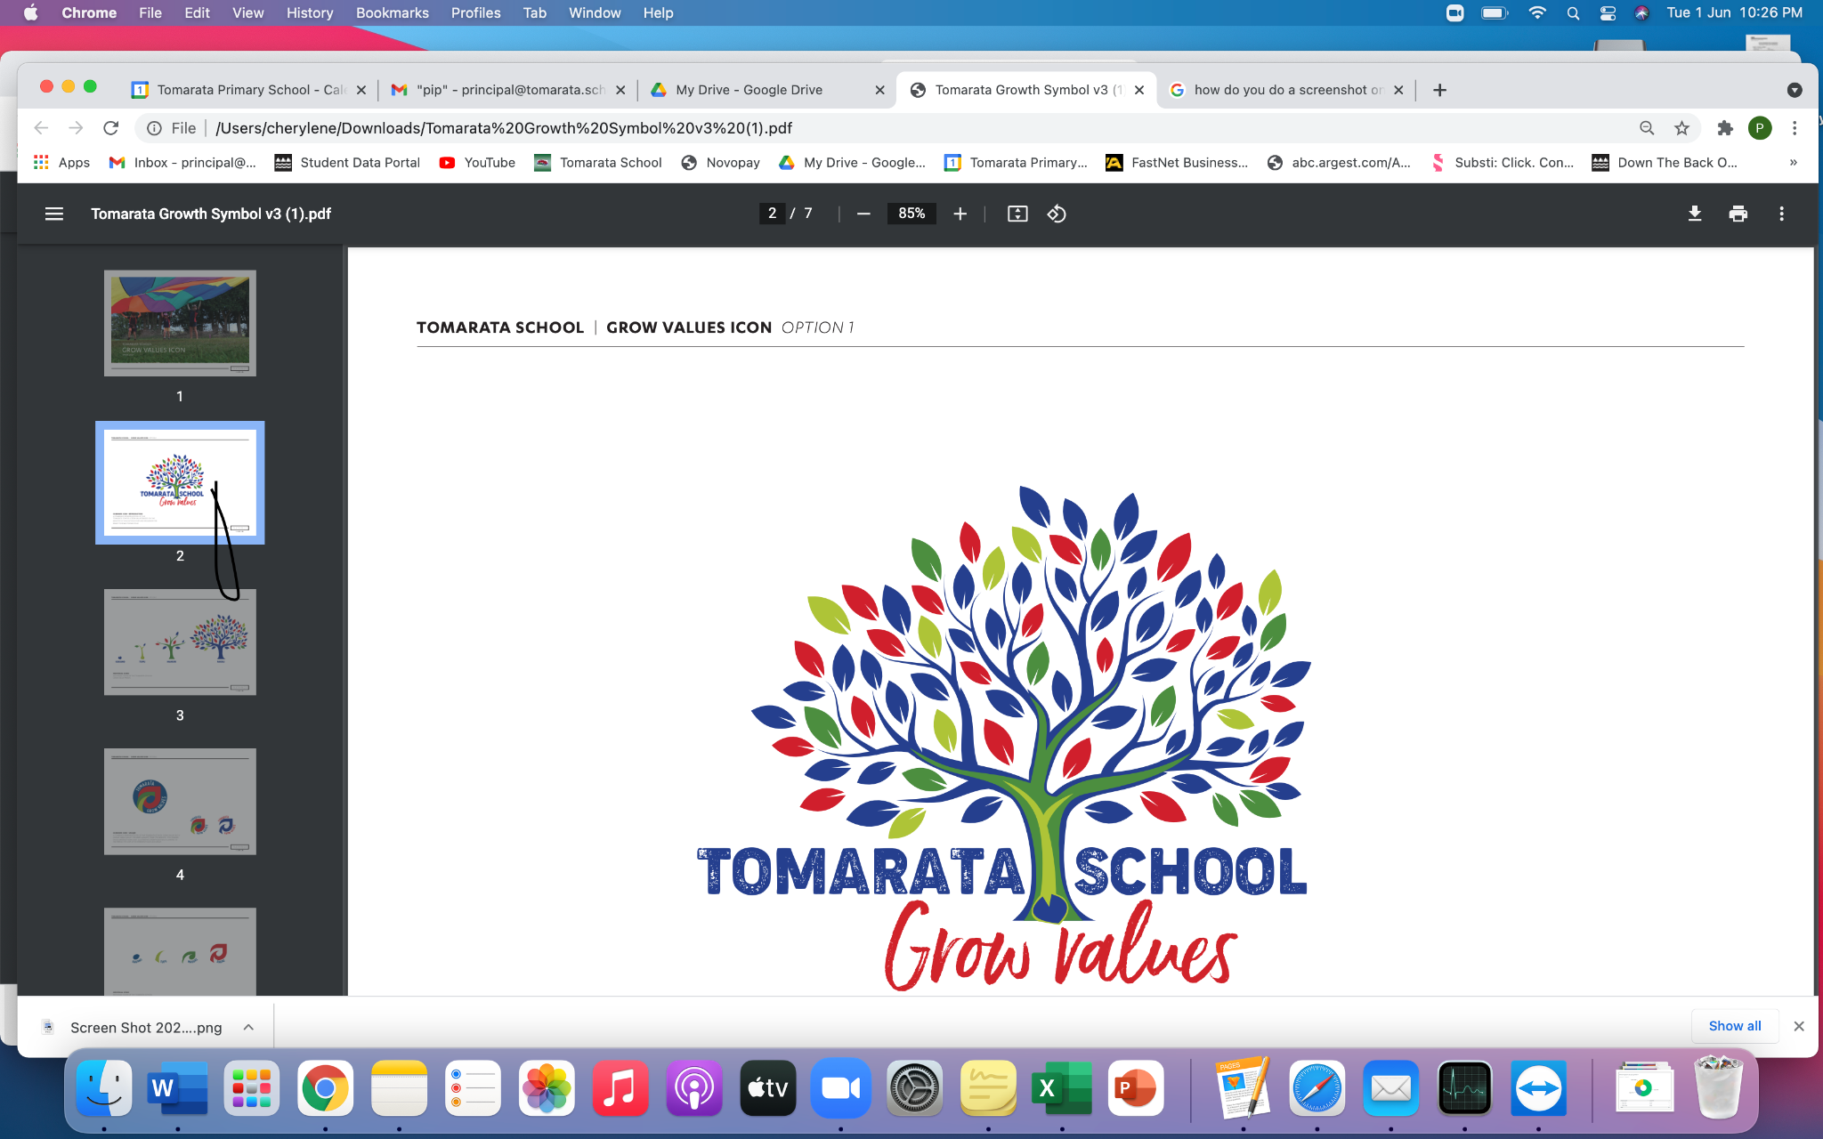

Our Vision

Whether it be in the school garden, hunting for bugs, local planting days or learning about the trees and native birds at our special bush block, the responsibility of being Kaitiaki develops naturally, starting with a love and enjoyment of playing in the outdoors.
These activities are part of our Environmental local curriculum that have been one of the changes at Tomarata School over the last year. We are joining the Kaipara Sustainability group & Ngati Manuhiri for a whole school planting day at the end of this term. This will become a regular event in future years. Our school has established bee gardens, butterfly gardens, vege gardens & flower gardens, the caring of which have become a part of weekly programmes. There will be a further development of all these areas as part of our annual plan for 2022. Our wonderful nature classroom is enjoyed by every class, every term, as part of the classroom release programme run by Matua Chris. All of these special learning opportunities are available to every student who attends Tomarata School.
Tomarata School Shared Vision can be read in full here.

Reminders
Head Lice are those friendly little critters that like to share their joy among every child they can. Please check your children’s hair regularly, & we encourage long hair to be tied up.

PB4L Focus
Our PB4L focus this week is on using appropriate manners when entering the office, & going to the sickbay. Every child that goes to the sickbay has their visit recorded on our student management system as part of school records of injuries & treatments.
Tomarata School Behaviour Plan can be read here

Shout outs
Students
Awesome effort to the following students who received the Values mascots on Monday: Todd Rm 6 for Growth; Eli Rm 3 for Respect; Oliver Rm 7 for Ownership ; Hope Rm 5 for Working Together Harmoniously.
Well done to Ava from Room 2 for marvellous maths and Annabelle in Room 3 for perfect poetry .You guys are AWESOME!!
Congratulations to the following students who received prizes at assembly last week: Khodi Room 5 for Ownership; Jet Room 6 for Working harmoniously; Molly Room 5 for Respect; Lucas Room 6 for Respect.
Excellent role modelling of our Values from Hope Henderson, who was nominated by a parent for a shout out after she took care of her daughter. You make me proud Hope!
Finally a well deserved accolade for Molly Barnes in Room 5 who has become the Deputy House Captain for Kakapo & Cole Costello Room 5, who has been appointed to the Student Voice Council. We are very proud of you both.
Community
Huge thanks to Denise Anderson (again) for her donation of lovely shrubs for our deck pots. We appreciate your support! Big shout out to Talia Watson-Walker who has been coaching our children in preparation for our upcoming soccer/hockey tournament. Your expertise is very welcome.
Appreciation claps to Sarah Bray who assisted when our Room 6 students were being taught about layering our compost bins properly, & for taking on the job of Grant applications for me. So very grateful Sarah!
Pakipaki to Te Whai Trust & Kiri Eriwata who have arranged for some cool jackets to be given to some of our students for Winter, free of charge. Te Whai is a wonderful community organisation that does so much for our local families & whanau. Thank you for thinking of our Tomarata community!

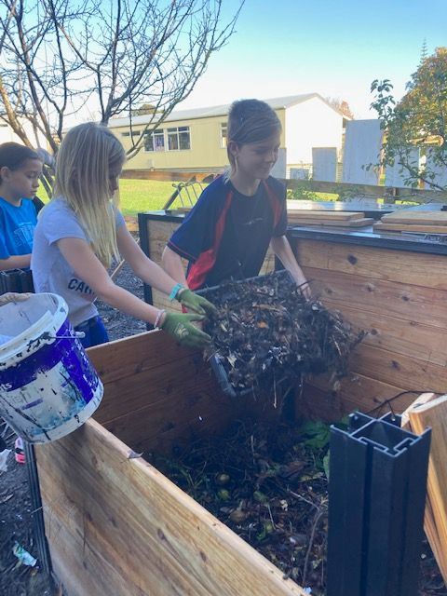

Welcome to...
Mrs Lynette Haddow who will be filling in for Mrs Kirsten Forno-Watson for the rest of the year. We are glad you are joining our Tomarata School whanau.

Parent Forum
On Tuesday next week we will be holding our Parent Forum. This is an open invitation to any parent to come and have an informal chat & to ask any questions about what is happening at school. The first forum was held last term. Just a reminder this is not a time to air grievances or grizzles, rather a time to get any questions answered, and to give suggestions for improvements or new ideas.

Helping Hands Update
We are going to need lots of helpers for the hockey soccer day at Port Albert on Friday the 18th of June for our sausage sizzle and food sales..
We will also need someone to help with transporting the bbq and tables out to the Port Albert soccer club in the morning by 9.00am.
Anyone that is able to help please let me know
Erica Casey helpinghands@tomarata.school.nz

BOT Update
Introducing our new Board Chair Jason Kerrisk. Jason has been on the Board as Deputy Chair, & also taking care of the property portfolio. Congratulations on your new role Jason! Welcome to Hagan Logue who has been co-opted onto the Board. Hagan comes with educational & financial knowledge & will be a fantastic asset to the school - Betsy Tipping
Jason Kerrisk boardchair@tomarata.school.nz
House Captain Hello
Do we have a grandparent or parent who would be willing to help our House Captains build their roadside stall? We really need some assistance & expertise PLEEEASE!!!
Just for a Giggle:
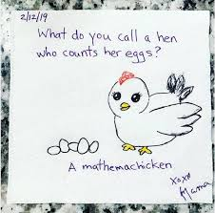

Jackets.
There are still some jackets available
Girls 3yrs,5yrs,6yrs,7yrs,8yrs,10yrs
Boys 2yrs,3yrs,5yrs,8yrs
There is 1 jacket per size left they are beautiful warm jackets if you would like one for your child please contact the office asap

Community Notices.

Tomarata Playcentre
619 School Road, RD 4, Wellsford
tomarata@Playcentre.org.nz
09 423 9074
Tuesday, Thursday & Fridays 9.30-12pm

CATWALK ARTS WEARABLE ART AWARDS Sat 28th August 2021 Mahurangi College. Please see our facebook page for more information

