Newsletter
Term 2 Week 4
May 26, 2021

Whats on?
27 May | Helping Hands Lunch Orders  Liam- cricket lessons
28 May | Book Week finishes  Book Week Parade 8:45 am  Whole school assembly
31 May | Start of testing week
2 June | Year ⅞ Tech
3 June | Hearing & Vision testing
7 June | Queen’s Birthday-no school
8 June | Parent Forum 6 pm in staffroom
9 June | Year ⅞ Tech  Footsteps Dance Company starts
11 June | Whole school assembly
14 June | Creatives in Schools Art Rooms 5, 6 & 7 with Geva Downey
17 June | Sausage Sizzle & Pizza Whanau Fun nite 4 pm onwards

Birthdays

Mrs Neel’s Musings

Dear families & whanau
Kia ora, kia orana, talofa, malo e lele, kon’nichiwa, hello
Tomarata School is part of the scheme where the Ministry gives us money per student to cover all school trips/activities; visiting shows; all Sports bus trips; school fees & a myriad of other costs .This means that we are not constantly asking parents for money which I think is a definite plus for families & whanau.
Yesterday I had a conversation on trips with a parent. Trips are an important part of school life. However gone are the days that a class goes on a trip every term, “just because”. Trips are planned for educational reasons to support the learning that has happened that term. We are also bound by very rigid Health & Safety rules before any trip can take place. These days most parents are both working, so sometimes getting the correct adult ratio to meet those rules is difficult. We also have the added disadvantage of being isolated so that increases the transport costs & travel time hugely. All of this, plus entry fees to some activities, limits the amount of trips that we can send the students on. I would love to send our children to the Zoo & such places, but we just can’t. Some years your child may not go on a trip at all, but we will try our best to give them those experiences when we can.
principal@tomarata.school.nz
____________________________________________________
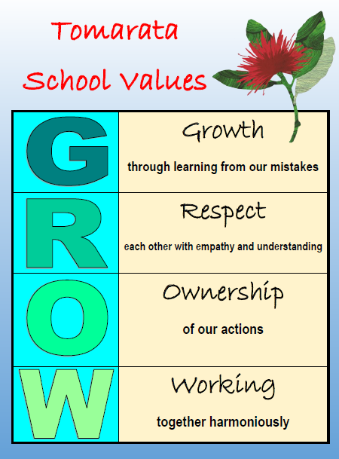
Have you voted for our new GROW symbol yet?

Our Vision
Our outdoor kids spend time in our spacious grounds & rural environment with a range of creative activities which encourage sustainable innovation. Our children definitely love the outdoors, usually barefooted. We are extremely lucky that we have such big areas for them to play in, & they have not been swallowed up by buildings. Having trees to climb, dirt mountains to dig in & huts to build teach our children resilience & allow them to be creative in design & play. We are slowly building up our sustainable innovations & experiences- composting is a prime example. Any GREEN waste that you have at home can be brought to school to go into our compost bins. We also intend to have 2 bins at the school gates that whanau can deposit food & green waste in to help build our compost up. The children have been taught how to layer properly last week. We will then use the resulting compost in our gardens as well as bag & sell in our stall when it is built.
Tomarata School Shared Vision can be read in full here.

Reminders
The Book Fair is open after school today & tomorrow. Every book bought goes to the amount of books donated back to the school. Great for birthdays & Xmas presents ( arghh did I just mention the C word!). Don’t forget our Character Parade at 8:45 am on Friday.
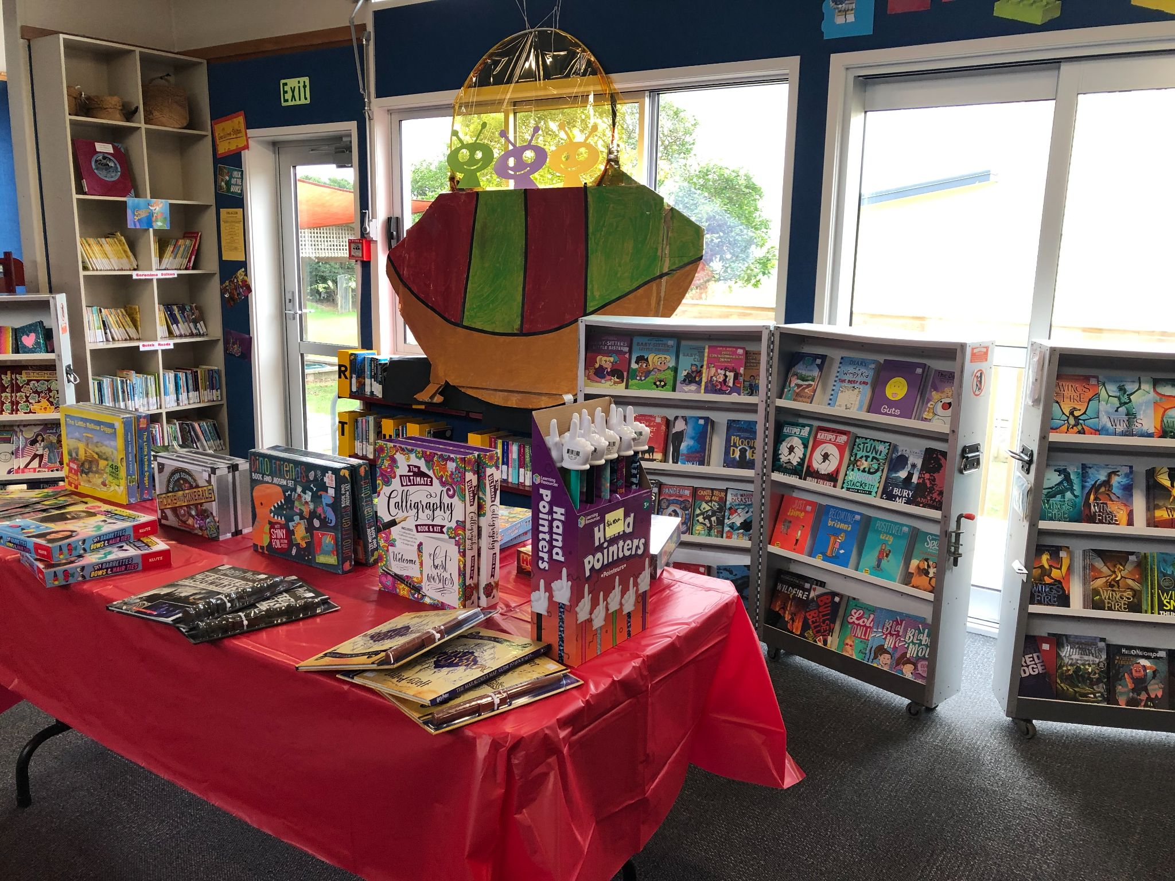

PB4L Focus
Our PB4L focus this week is on using the sandpit properly. It is surprising the age range of children that use the sandpit- from New Entrants to Year 8. Again this is an area where children can be creative in playing in. I have also added a link to the school Behaviour Management Plan so that everyone can look at it if need be.
Tomarata School Behaviour Plan can be read here
Andie McGuiness andie@tomarata.school.nz

Shout outs
Students
Awesome effort to the following students who received the Values mascots on Monday: Taine Rm 6 for Growth; Arya Rm 7 for Respect; Cole Rm 5 for Ownership ; Kyle Rm 6 for Working Together Harmoniously. Well done to Jacko, Harper, Felix & Tamihana from Room 2 for marvellous maths; Jackson in Room 7 for wonderful writing; and Blake in Room 7 for rad reading! You guys ROCK!
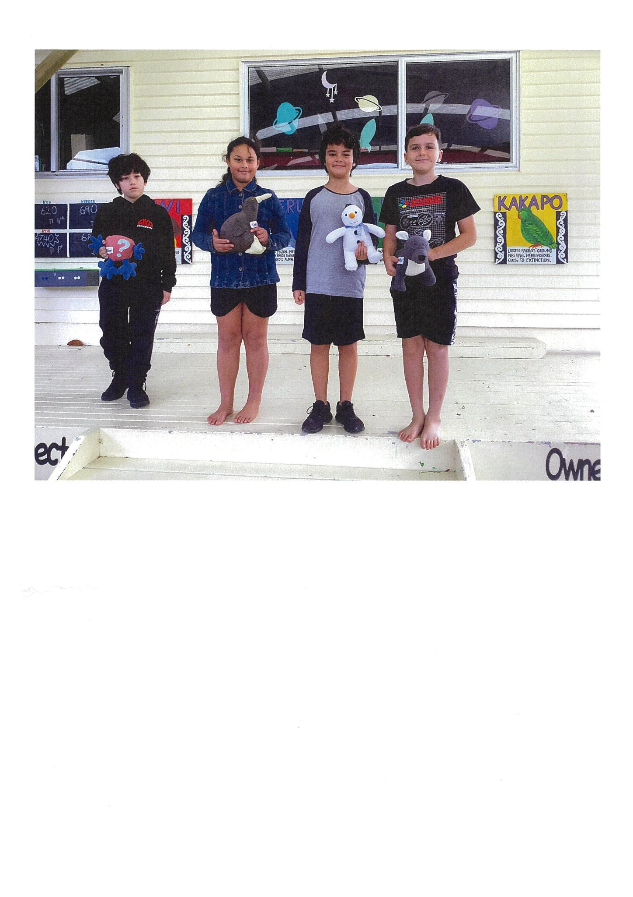
I would also like to do a Pinkaliscious shout out to all the students who wore pink on Friday in support of anti bullying. We looked pretty perfectly pink!
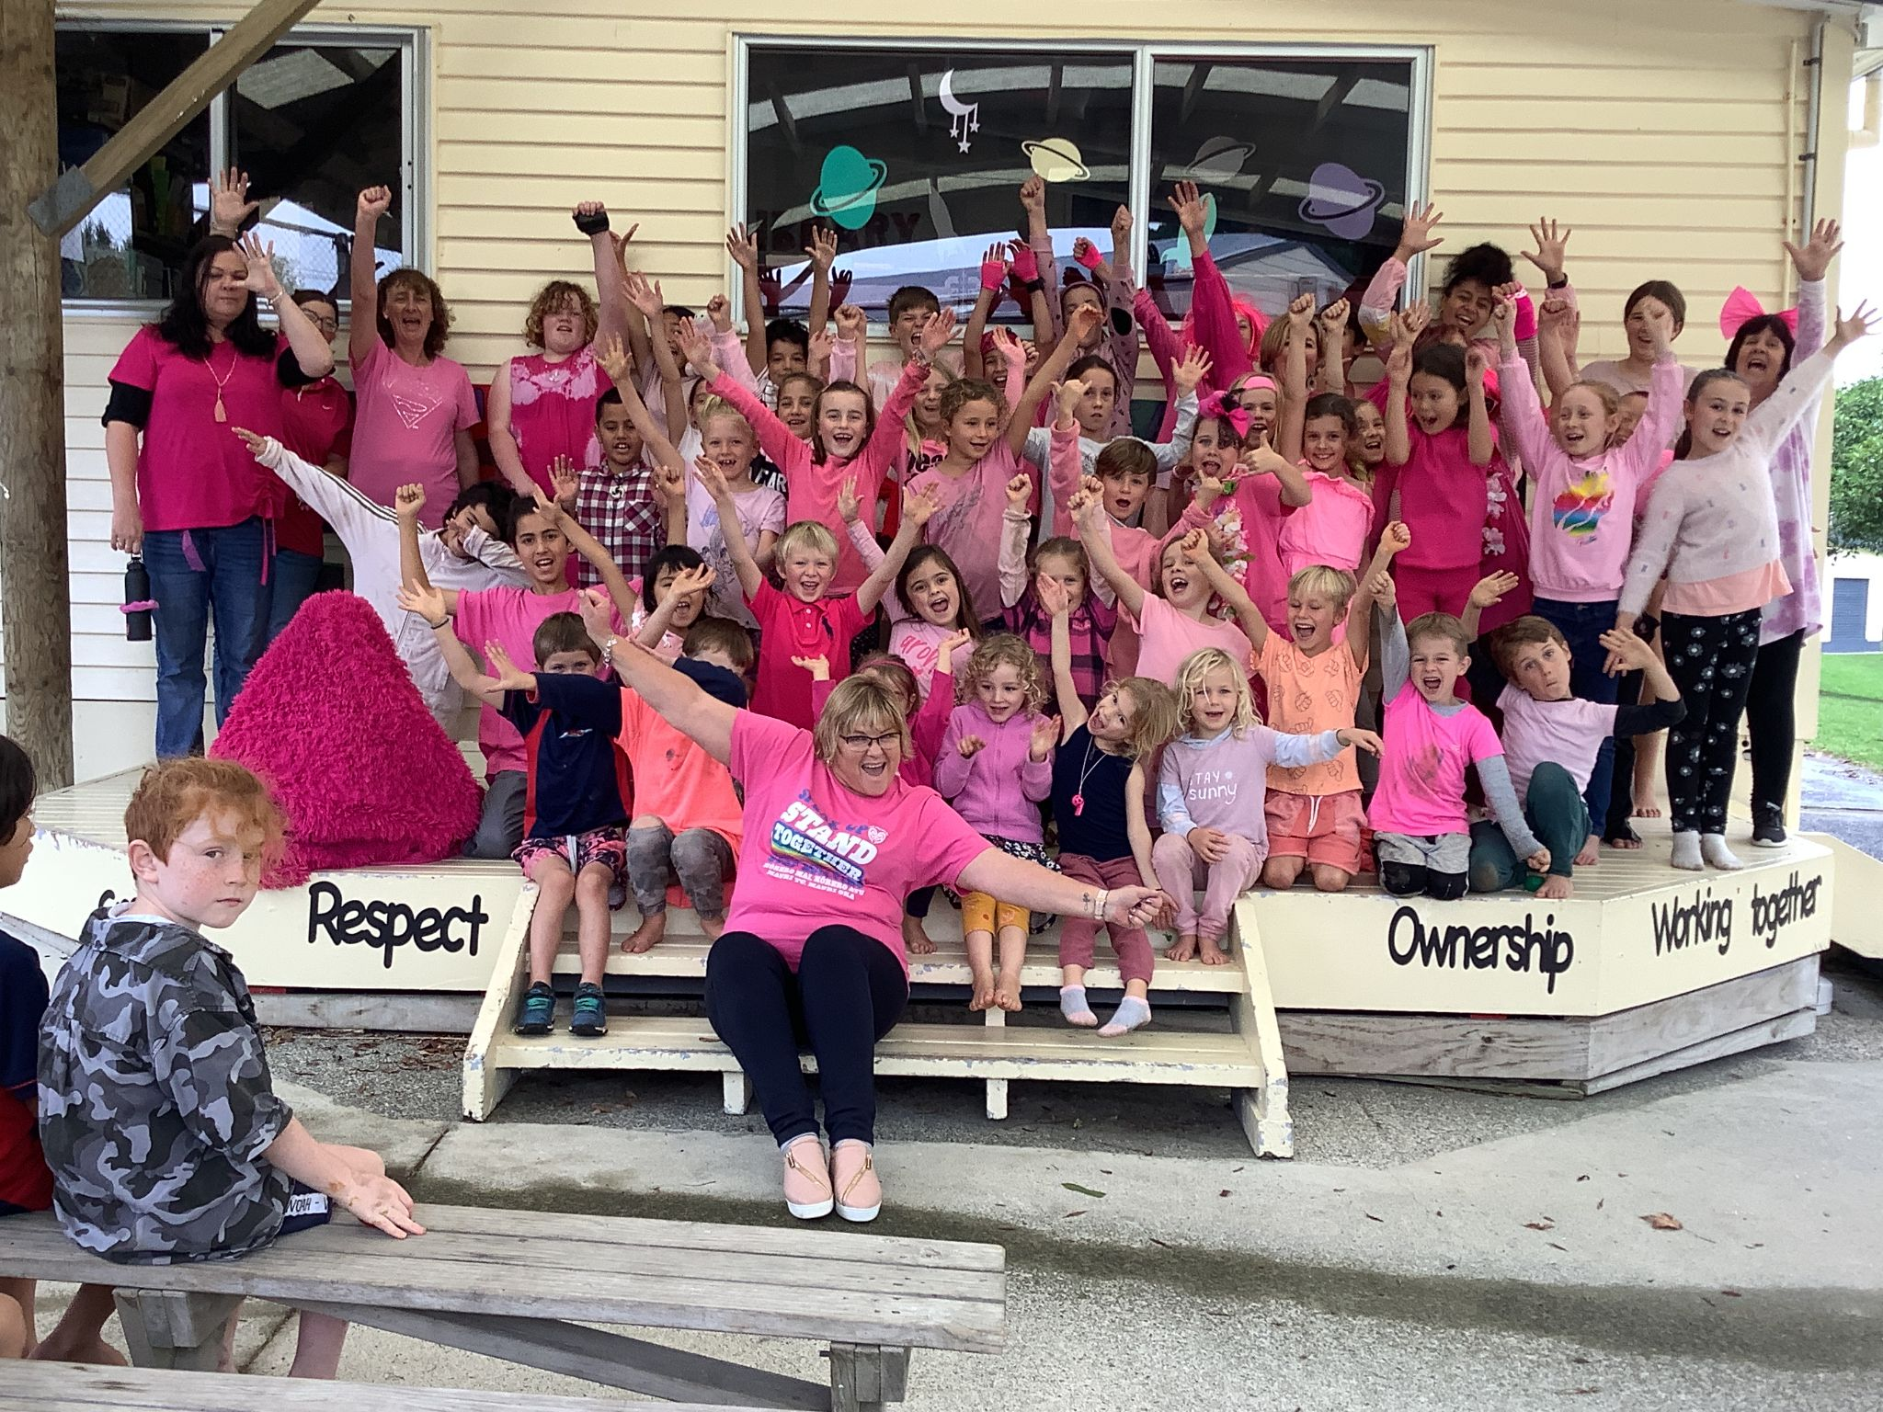
Community
Still looking for small shrubs or plants that we could replant our pots for the office deck with, we would be very grateful!
Thanks to Sarah Bray & Sherryll Burke who have taken on Parent Reading. Your support is very much appreciated.
Did you know that Tomarata School has a defibrillator in our sickbay? We are looking at getting an outside cupboard for it to be housed in, so that it is accessible by the community if needed.
Thanks to our washing fairy Denise Anderson, & for her donation of our new sickbay quilt. You are so kind.

Welcome to...
Kaya Edmonds-Griffiths in Room 5. We hope you enjoy being part of the Tomarata School whanau.

Help Needed
Our Breakfast Club is working well with the lovely Rochelle, Sara and Simone who supervise on Mondays, Wednesdays & Fridays. Ideally we would love for it to be open every day. If you think you could do a Tuesday or Thursday morning from 8-8:30 am please let Vicki know in the office

Helping Hands Update
Lunch orders will be happening tomorrow 27 May. Please have the correct change if possible.
Erica Casey helpinghands@tomarata.school.nz

BOT Update
Reminder: Board meeting is TONIGHT
Please come along to our meeting tonight at 7pm. These meetings are held monthly in the boardroom at Tomarata School and are open to the public. The triennial election is next year and in line with our succession plan, we are looking to co-opt a couple of new members prior to this. You do not need to be a parent to be on the board, so if you are interested (or know of anyone who can bring something special to our school) please get in touch! I will be stepping aside as Board Chair tonight, so I look forward to introducing you to your new chair next week! This has been a hugely rewarding and fulfilling role, but I am embarking on further study so will not have the time (or brainpower!) to do the role justice.
Betsy Tipping boardchair@tomarata.school.nz
House Captain Hello
Many thanks for your support of the Bake sale yesterday. We raised $168.30 towards the cost of building our Tomarata School stall.
Just for a Giggle:

