Newsletter
Term 2 Week 3
May 19, 2021

Whats on?
21 May | Pink Shirt Day
24 May | Book Week starts
25 May | House Captains Bake Sale
26 May | Year ⅞ Tech  BOT meeting 7 pm
27 May | Helping Hands Lunch Orders  Liam- cricket lessons
28 May | Book Week Parade  Whole school assembly
31 May | Start of testing week
2 June | Year ⅞ Tech
3 June | Hearing & Vision testing
7 June | Queen’s Birthday-no school
8 June | Parent Forum 6 pm in staffroom
9 June | Year ⅞ Tech  Footsteps Dance Company starts

Birthdays

Congratulations to Corbin Pieper

Mrs Neel’s Musings

Dear families & whanau
Kia ora, kia orana, talofa, malo e lele, kon’nichiwa, hello
This week schools nationwide are discussing ways on how to be a Bully Free Zone. The phrase bullying is often used freely, so it is important to know what constitutes bullying. It is when a person does something to another that is repeated; unwarranted; unwanted; causes emotional or physical harm. It is important to make the meaning clear as sometimes we get reports of bullying when it is a one off incident.
Our focus for this term along with Pause, Breathe, Smile is Te Whare Tapa Wha. This translates as “The House with 4 Walls”. It is a model of Hauora (wellbeing) & is used in our Health curriculum. The 4 walls of the whare are: mental & emotional wellbeing (taha hinengaro); family & social wellbeing (taha whanau); physical wellbeing (taha tinana); & spiritual wellbeing (taha wairua). If you look in each class you will see somewhere a model of the whare. Our children will be learning about what activities enhance their 4 walls, & what activities cause stress ,allowing them to be more in awareness of themselves & their actions & reactions.

principal@tomarata.school.nz
____________________________________________________
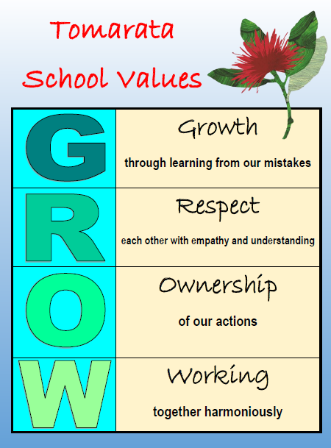

Our Vision
We learn & use te reo across work & play- Maori culture is embedded throughout our school & we celebrate life with our own unique activities- You will hear te reo being spoken by staff and students every day in a variety of activities. Our goal is to normalise the use of te reo, & for staff & students to have confidence in speaking it. We are very much at the start of our te reo journey at this point in time. Te Ao Maori ( culture) is very much integrated into every study or Inquiry learning that we do. It is important to incorporate the maori worldview into all our planning. There are many activities that are unique to Tomarata School- our Ag day being one of them alongside such events as the Fireworks Night. We intend on making our Local Curriculum completely unique to our wonderful school, especially with regards to our environment.
Tomarata School Shared Vision can be read in full here.

Reminders
We expect all children to read at home every day. As part of their stationery each child has a book bag. Please note that if your child does not bring their book bag to school, and/or fails to return books ,we can’t send home readers. They get damaged if not in a bag, and each individual book costs approx $12-15 each! We buy sets of 8 readers at a time, & simply can’t afford to replace them. So please, especially for our Junior children, can book bags & readers come back to school daily-thanks!

PB4L Focus
Our PB4L focus this week is on Wet day procedures. Every class has specific activities they can do inside. Our Junior classes also have senior students as monitors to supervise their activities. It is very timely as the weather has definitely made a change in the last few days...brrrr.
Andie McGuiness andie@tomarata.school.nz

Shout outs
Students
Awesome effort to the following students who received the Values mascots on Monday: Te Awanui Rm 3 for Growth; Lucas Rm 6 for Respect; Rosalie Rm 7 for Ownership ; Molly Rm 5 for Working Together Harmoniously. Well done to Noah in Rm 7 for brilliant independent writing. Way to go Noah
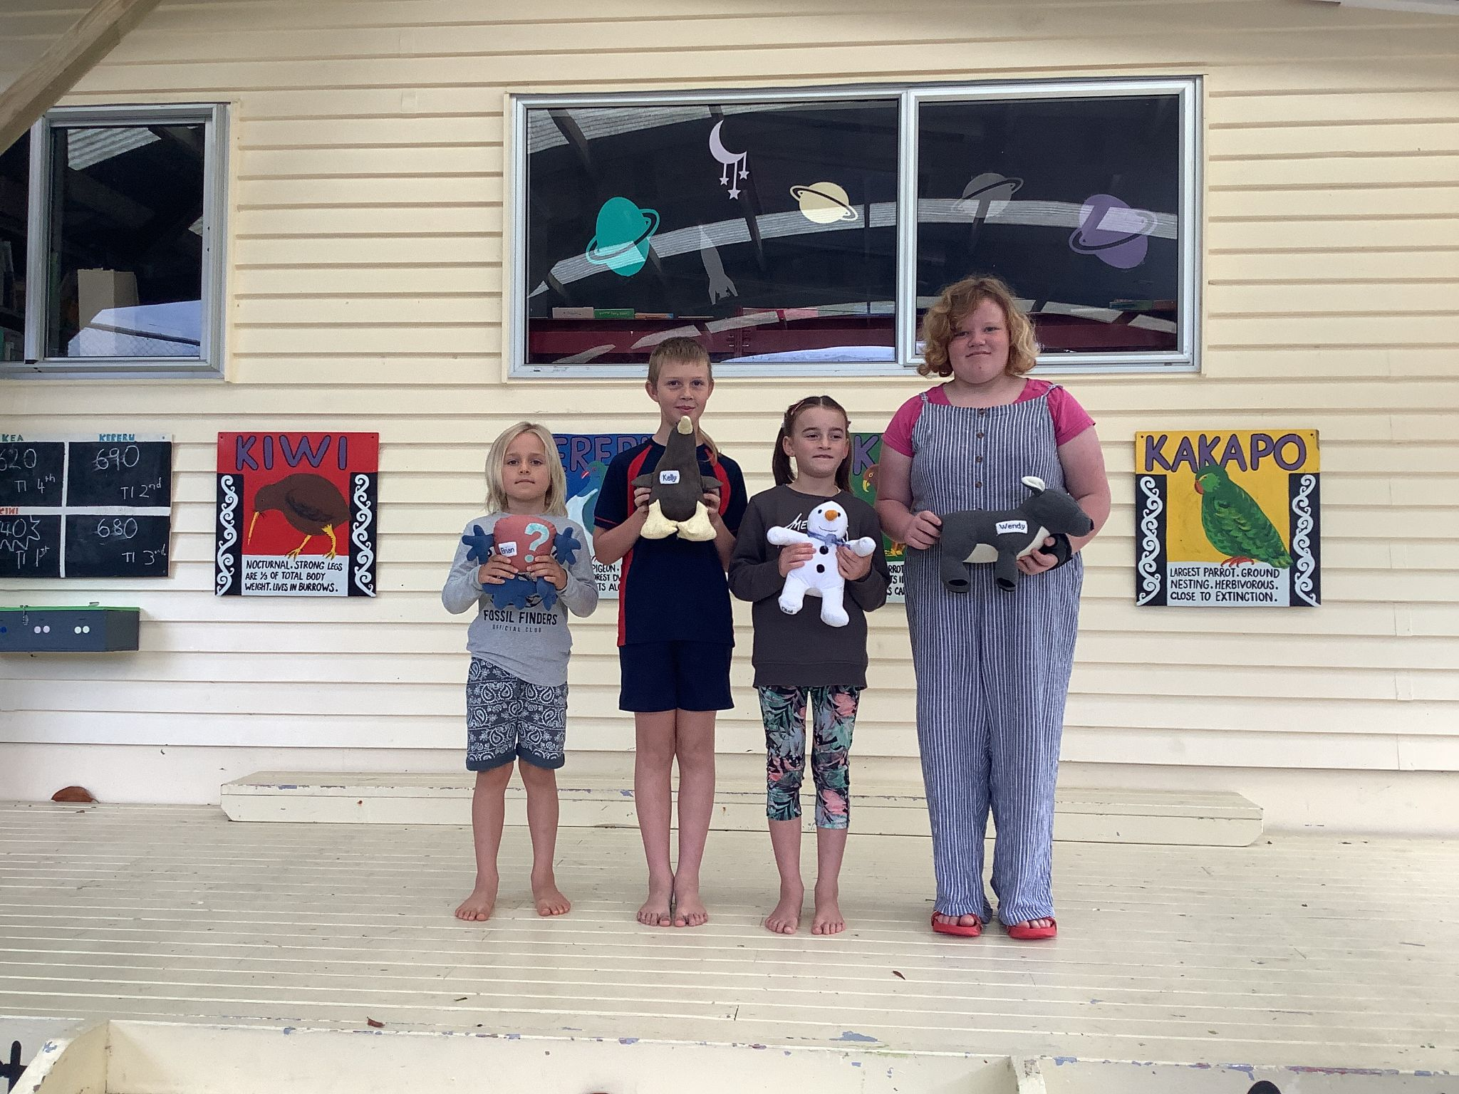
Community
I had a wonderful meeting with the Fireworks committee of parents this afternoon. My goodness they have made so many amazing plans. It will be another fantastic event to look forward to. So WATCH THIS SPACE!
A huge thanks to Pip White who has been working ona symbol for our GROW values. We will send out some options for you all to vote on soon.
If anyone has any small shrubs that we could replant our pots for the office deck with, we would be very grateful!

Welcome to...
Mrs Lynette Haddow who will be covering for Kirsten Forno-Watson for the next couple of weeks in Room 5.

Help Needed
We are still looking for someone who has some spare time & could assist with Grant applications. We especially need help to buy resources for our STEAM room.

Helping Hands Update
Lunch orders will be happening next week on the 27 May. Please have the correct change if possible.
Erica Casey helpinghands@tomarata.school.nz

BOT Update
What a great start we have had to the term! Before the holidays I was lucky enough to attend the NZSTA National Conference held in Rotorua. It was inspiring and a wonderful opportunity to grow in my learning.
We are having our monthly board meeting next Wednesday (26th May) and you are welcome to attend. These meetings are held at Tomarata School at 7pm and are always open to the public. A full list of dates are on the website calendar and the agenda is available online a week in advance (https://drive.google.com/folderview?id=1nxvV1Vk7lUqwBNh9SAvDz-QbcELLRpdN). Next year is a triennial election so if you're wanting to get involved it would be wonderful to see you there!
Betsy Tipping boardchair@tomarata.school.nz
Just for a Giggle:
