Newsletter
Term 2 Week 10
July 7, 2021

What's going on?
8 July | Whole school planting day-Tomarata Lakes
9 July | Parent Teacher Interviews: children at home  Last day of Term 2
26 July | Term 3 begins
4 August | New parent’s morning tea  Yr ⅞ tech
6 August | Whole school assembly
10 August | Parent Education session on HERO 3-4 pm
11 August | Year ⅞ tech
18 August | Rodney College visiting Year 8’s  Year ⅞ tech
20 August | Whole school assembly  Possible DISCO
24 August | Parent Education afternoon 3-5 pm on Reading
25 August | Rodney College Open Evening 4:30-5:30 pm
26 August | Parent forum 6-7 pm

NB: Friday 9 July is like Day 1 interviews. School is open for interviews only. The children DO NOT come to school as usual. They can come with you ( parents) for the Interviews if you wish them to be there.

Birthdays
Eli Prater & Arya Mitchell Room 7

Mrs Neel’s Musings

Dear families & whanau
Kia ora, kia orana, talofa, malo e lele, kon’nichiwa, hello
It has been a long term of hard mahi & we're sure that everyone is looking forward to the holidays. Mid-year reports go live on HERO tomorrow. Please log onto HERO & look out for these.
Maretta Hodgson, the Public Health Nurse will be doing some wellness checks in early Term 3. If you would like your child checked, please send a message on SEESAW to your child’s teacher, or to Vicki in the office.
Eldest & only children received the Show day booklet yesterday. If this has not made it home to you, please ask for one at the office. It contains rules etc for the different categories & competitions on the day.
Below is the student achievement data for mid year across the 3 core curriculum areas. It is very pleasing with our children well on the way to being at the required level by the end of the year. Remember it is normal to be “working towards” half way through the year.
Reading
Counts | Mid 2020 | End 2020 | Mid 2021 | End  2021
Well above | 0 | 0 | 0
Above | 0 | 5 | 4
At | 5 | 41 | 43
Towards | 11 | 11 | 20
Towards with support | 2 | 17 | 12
Total At or above | 5 out of 18 | 46 out of 74 | 56 out of 89
Percentage At or above | 28% | 62% | 62%

Writing
Counts | Mid 2020 | End 2020 | Mid 2021 | End 2021
Well above | 0 | 0 | 0
Above | 0 | 2 | 1
At | 1 | 41 | 41
Towards | 11 | 25 | 27
Towards with support | 5 | 6 | 10
Total At or above | 1 out of 17 | 43 out of 74 | 51 out of 89
Percentage At or above | 6% | 58% | 57%

Maths
Counts | Mid 2020 | End 2020 | Mid 2021 | End 2021
Well above | 0 | 0 | 2
Above | 0 | 3 | 6
At | 0 | 27 | 40
Towards | 0 | 33 | 27
Towards with support | 0 | 7 | 4
Total At or above | 0 out of 0 | 30 out of 70 | 57 out of 89
Percentage At or above |  | 43% | 64%

Enjoy the break, & we will all be back refreshed in two weeks time!
principal@tomarata.school.nz
__________________________________________________

Our Vision
First we realise we must understand the child, then we must teach them in a way they understand.
Getting to know your children is paramount. As I have said before we use a variety of opportunities & strategies to do this. Day 1 interviews; parent/teacher interviews; observations in class; discussions with children; assessments; goal setting; knowing passions. These are all ways in which we learn different facets of each child. When we pick up different abilities in learning & behaviour this also allows us to know what strategies or procedures to use with your children. Some learn by doing, some by seeing, some by hearing. Doing this is a challenge, but one we take on to the best of our abilities. Sometimes we require outside agencies to help us with this, but however it happens, we try to teach them in a way that works for them.
Tomarata School Shared Vision can be read in full here.

Reminders
We have lip balm, earrings and lemon honey for sale all made by Room 3, Room 7 or crafty kids at lunchtimes. Please support the children’s efforts by purchasing them from the office.
Also please return all Show day trophies from last year asap.
Don’t forget we have a donation box for old mobile phones at school, to donate to Starship. It is in the office.

PB4L Focus
Our PB4L focus this week is on being able to use the Library correctly. This is teaching children to take responsibility for borrowing books; using them in the right way; & then returning them on time & correctly. It reinforces the values of Respect (for property) & Ownership of their actions. This also teaches them the expected behaviours for when they use public libraries. This can be reinforced at home by how children treat their own books, & books belonging to their siblings or others. It also reinforces the concept of borrowing items correctly as adults.
Tomarata School Behaviour Plan can be read here

Shout outs
Students
Awesome effort to the following students who received the Values mascots on Monday: Archie Rm 6 for Growth; Aurelia Rm 7 for Respect; Jacko Rm 2 for Ownership ; Molly Rm 5 for Working Together Harmoniously.
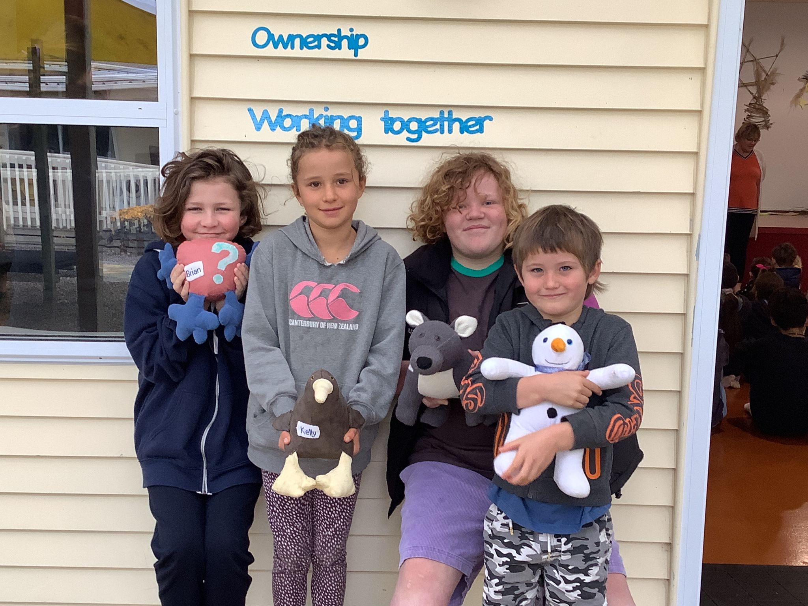
Congratulations to the following student who came to me with some marvellous Maths knowledge of addition using double digits, knowing his place value. Cody Davis you are so cool!
Yummy thanks to Room 3 who shared their lemon ice-cream with me. It was deeee-licious .

ART PAGE.
Room 5 have continued working together harmoniously when doing art with Geva and Mindy. They modelled tuakana terina beautifully when making their own paint out of clay dug from our school grounds with Room 2 children.
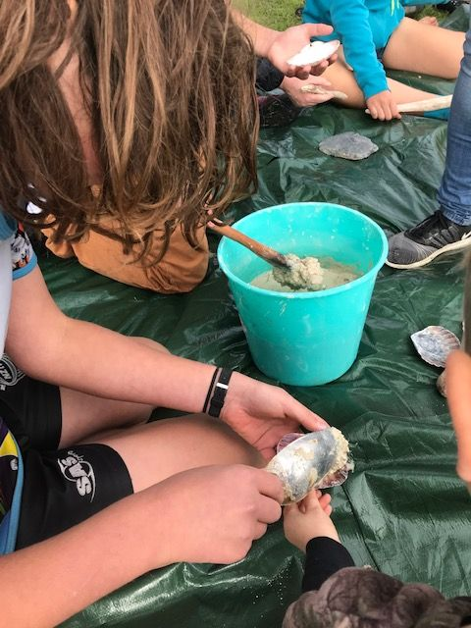
They displayed manaakitanga while preparing and mixing the pigments into the clay. They used turmeric, plants like nasturtiums, & charcoal made in our pizza oven.

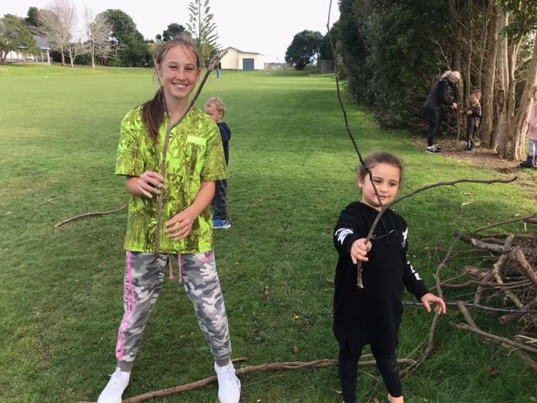
Sally from the Wellsford Library came to share the activity as well, as she wanted to see for herself the amazing mahi Tomarata School children are doing in Visual Art.
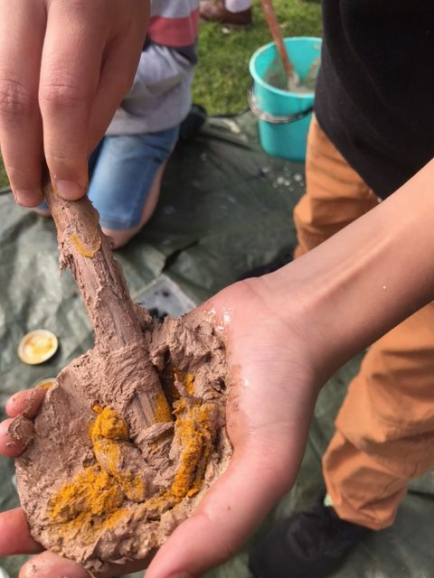
How wonderful are our kids?
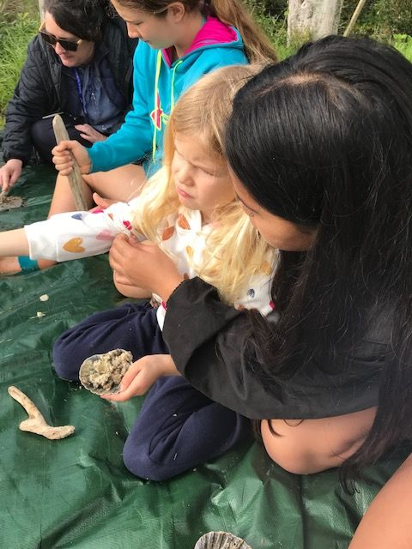

Community
Our mid year reports will be ready to be accessed by you digitally, using HERO, tomorrow. Look out for the information on how to access them. Remember to book an appointment online, for an interview with your child’s teacher . Please go to www.schoolinterviews.co.nz & enter the code wxdjp.
Attention dairy farmers! Please remember that AFFCO & Wrightsons have donation schemes to schools for bobby calves etc These are very worthwhile for our school.

Parent Forum
Our next Parent Forum will be on Thursday 26 August at 6 pm in the staffroom. All welcome
We will also be holding a Maori Whanau Consultation night on Thursday 2 September at 6 pm. We would like our Maori whanau to attend, as well as in other interested families, to discuss what Tikanga Maori could look like at Tomarata School.
Helping Hands Update
On Saturday the 3rd of July the Helping Hands hosted the Veteran’s Car Rally Group at school. They supplied hot soup, Devonshire scones and other baking to feed hungry & cold drivers. I wish to give my heartfelt thanks to a VERY SMALL group of people who helped on the day. Thanks & aroha to Erica Casey & Robyn Sibtsen who stayed all day, Jeanette Mabin & Sara Pengelly who also covered hours, & Maddy Wallace ( an ex pupil) who helped. Ka pai to our fabulous bakers especially Jordan, Denise, Paula & Rachelle. We really do need more parents to join this hardworking band of helpers. It is a big ask for 3 parents & 1 teacher to shoulder the load of fundraising for our school. Please consider joining & contacting Erica if you have questions.
To contact HH please email Erica Casey helpinghands@tomarata.school.nz

BOT Update
Our next Board meeting is on Wednesday 28 July at 7 pm in the Boardroom. All are welcome.
To contact the BOT please email
Jason Kerrisk boardchair@tomarata.school.nz
House Captain Hello
The House Captains with the assistance of Chase Harris in Room 5, & Geva Downey, are painting their own version of the values tree in the hall. It will look fabulous when it is completed.
HERO
For information about HERO, including how to log in go to
http://go.linc-ed.com/

Community Notices.
CATWALK ARTS WEARABLE ART AWARDS Sat 28th August 2021 Mahurangi College. Please see our facebook page for more information
Tomarata Playcentre
619 School Road, RD 4, Wellsford
tomarata@Playcentre.org.nz
09 423 9074 Tuesday, Thursday & Fridays 9.30-12pm

Outdoorsy NZ fundraising evening at the Tomarata Forest Reserve Hall 27 July 7-8 pm with Michelle Morpeth. Earlybird group ticket available for a limited time ( ends 25/7) $25 pp ( group 6+) or $30 online purchase. $35 at the door.
School holidays programme at the Wellsford Library. Go into the Library & get into any of the activities, any day of the week ,at any time. Look out for some of our students taking Art lessons!
Just for a Giggle

