Tomarata School Board of Trustees Minutes
Date: 19th February 2020 Location: Board Room
Attendance: Cherylene Neels, Sheila Russell, Jason Kerrisk, Chris Rhodes, Jeanette Mabin, Betsy Tipping, Joanne Tischik, Vicki Rambaud ( secretary)
Apologies: Nil

Welcome
Minutes of the previous minutes
Minutes of the meeting held on 11th December 2019 be approved and adopted as a true and correct record)
Jeanette/Betsy
Carried
001/19th Feb
Matters Arising
Nil
Declarations of Conflict of Interest
Chris CRT teacher
Betsy/ Cherylene
Carried
002/19th Feb
Correspondence
End of Statutory Intervention
Betsy/Cherylene
carried
003/19th Feb

Appointment of board chair & Deputy chair
Sheila Russell to be appointed Chair
Betsy/Chris
Carried
004/19th Feb
Betsy Tipping to be appointed Deputy Chair
Jeanette/Jason
Carried
005/19th Feb

Adoption of annual board plan
This is a living document. Jason to see if any property items could be added to help his planning. Strategic review to be updated with our new values to explore what they mean to us throughout the year. Addition of deep thinking review term 3-4 when STD came back in for progress check.
Motion to approve plans dates for rest of year
Chris/ Jason
carried
006/19th Feb

Review of Board Protocols 10.1.3 - expectations

Confidentiality Vision of Unity

C Rhodes Leave of absence T2
28th April May June Chris is away will be back for August meeting Resolution Granted leave of absence for three meetings but will try to Skype meetings from Japan

Cherylene/ Betsy
Carried
007/19th Feb
Approval of budget 2020
Budget not ready due to Ed Services delay. Kerry Dean to do with principal and to be finalised by electronic poll

Charter 2020- draft.
Documentation not submitted until meeting. principal handed out and read through at the meeting.
Addition of Ti Tiriti O Waitangi to be added into the wording.
Board to take and read - can pass by poll or convene a meeting if clarification needed

Analysis of Variance Reporting
Documentation not submitted as a board paper prior to the meeting. Principal explained the document. Board to take and read . can pass by poll or convene a meeting if clarification needed

Designation of Kerry Deans as Executive Officer for IRD
The Tomarata School Board of Trustees confirms Kerry Dean as Executive Officer for the purpose if MyIR File Login, and confirms Cherylene Neels as “Owner”, with delegated authority to appoint an executive office holder

Chris/ Jeanette
Carried
008/19th Feb

Pub Charity Application R7

Application approved for Pub Charity application
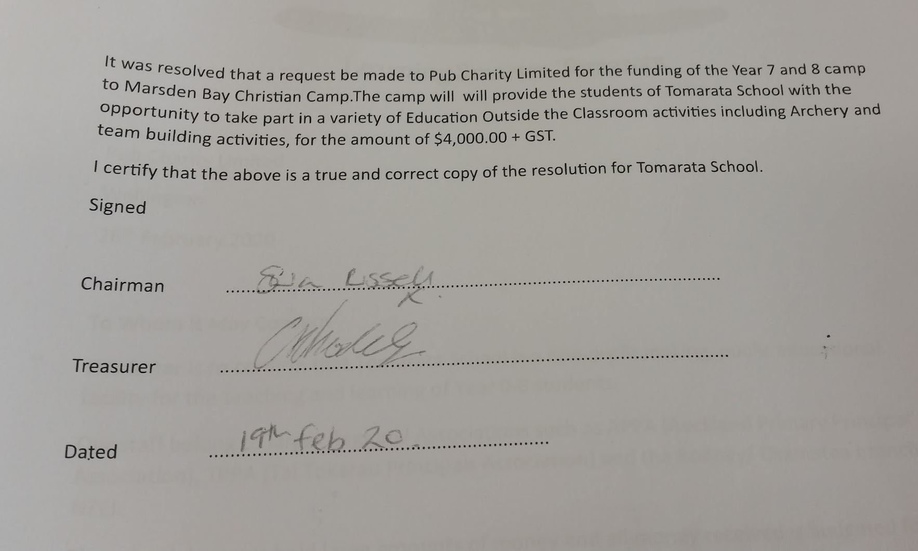

Joanne/Jason
Carried
009/19th Feb

Principals Report
Approve allocations of Units
Betsy/ Chris
Carried
010/19th Feb
Principal presented report
Cherylene/ seconded
Carried
011/19th Feb

Finance Report
Approval for payments
Following recommendation from the principal the Payments for ( November 2019), totalling $27,640.08 were approved.
Chris/Joanne
Carried
012/19th Feb

Property Report
$3313.50 approved for orchard area project
Quote from Gareth Taylor for installing posts has been received. Rails and chicken mesh are needed. old wood left over from dismantled classrooms will probably be enough, therefore we will have to purchase chicken mesh.

Accept quote for Alarm systems to be set up $1170.50 Insite Security
Jason/Chris
Carried
013/19th Feb

Board Discussions
First Aid refresher course for all staff members open to extra people to take part

Blanket consent form for trips specific activities eg , library , museum agreeing to low risk activities - Principal to look into this further

Wayne Hodgetts to do digger work for Pump track

Chicken Coop
Pergola, Pizza oven
Police vet for all Board members- agreed… to be arranged

Action List
All- Review Charter
Jason- Potentially add property items to annual board plan
Cher- Book First Aid Course
Vicki- Police Vet forms to BOT members

Meeting closed 9.45 pm
Date of Next meeting 18th March 2020

Signed as a true and correct record of proceedings

_______________ _______________
Sheila Russell
Chair, Tomarata School Board of Trustees Date

